This is the third in a series of messages. Two weeks ago (“Fill This House”), I began with this:
“God calls us, not to an experience (one-and-done), but to a lifestyle: repeatedly being filled with the Holy Spirit.
“Before there was a Western Church and an Eastern Church…
“Before there was a need for protestants and reformation…
“Before there were denominations…
“Before there were evangelicals…
“The Early Church was a Pentecostal church.
“We need to be continually being filled with the Spirit. If we will focus on what delights [God] today, we will ‘keep on being filled’ with the same Holy Spirit. If you want power, confidence, joy, peace, and more love in your life, ask the Spirit to come to you and do something new in you.”

Last Sunday (“This Is That”), I shared these thoughts:
Unusual things happened on the Day of Pentecost (Acts 2)—the sound of a roaring windstorm, flames of fire hovering above the disciples, they all were filled with the Spirit and spoke in tongues.
“Thousands gathered at the sound. Many people wondered about what they saw. Other people were confused by what they heard. Some people mocked.
“Now, filled with the Holy Spirit, Peter found a fresh boldness of faith. Along with the other eleven apostles, he stepped forward to speak to the wondering crowd: ‘What you see was predicted long ago by the prophet Joel.’ God promised, ‘I will pour My Spirit on My servants.’ This was that.”

Joel’s was an ancient prophecy, yet with a personal point. In the New Covenant which Jesus introduced, every hearer is personally accountable for his or her response to the Good News.

Vibrant Relationship

The Gospel of Jesus Christ is not a religion to be followed, or a philosophy to be admired, or an ethic to be practiced—it is a vibrant relationship with the Living God to be received, to be embraced, and to be pursued, every day, for the rest of your life.

As it says in the Bible:

^{John 5:39} “You search the Scriptures because you think they give you eternal life. But the Scriptures point to Me! ⁴⁰ Yet you refuse to come to Me to receive this life.

^{2 Corinthians 5:15} [Jesus] died for everyone so that those who receive His new life will no longer live for themselves. Instead, they will live for Christ, who died and was raised for them.

^{2 Peter 1:3} By His divine power, God has given us everything we need for living a godly life. We have received all of this by coming to know Him, the One who called us to Himself by means of His marvelous glory and excellence.

^{Romans 4:16} The promise is received by faith. It is given as a free gift.

^{Colossians 1:23} But you must continue to believe this truth and stand firmly in it. Don’t drift away from the assurance you received when you heard the Good News.

^{Matthew 7:7} “Keep on asking, and you will receive what you ask for. Keep on seeking, and you will find. Keep on knocking, and the door will be opened to you.

^{Mark 4:24} Then He added, “Pay close attention to what you hear. The closer you listen, the more understanding you will be given—and you will receive even more.

^{2 John 8} Watch out that you do not lose what we have worked so hard to achieve. Be diligent so that you receive your full reward. ⁹ Anyone who wanders away from this teaching has no relationship with God. But anyone who remains in the teaching of Christ has a relationship with both the Father and the Son.

^{Hebrews 10:36} Patient endurance is what you need now, so that you will continue to do God’s will. Then you will receive all that he has promised.

“A vibrant relationship with the Living God!” This is that! This is what Joel predicted. This is what Peter proclaimed. This is what we are living out today!

^{Acts 2:41 (NLT)} Those who believed what Peter said were baptized and added to the church that day—about 3,000 in all.

Last week, there were 10 children in our HandMade Children’s Ministries! How exciting! Four of them were here for the first time. It was challenging. We were not prepared for it. But the volunteer staff rose to the challenge—they flexed and innovated and served the children in unity of spirit, to the glory of God!

When Pastor Veronica reported it to me, I reminded her of the Scripture above. When God does such a miracle here—not if, but when—we will not be prepared either (who could be prepared to grow by 3,000 in a day?). It will be challenging, it will get messy, but it will be glorious, and God will work miracles among us, because it is HIS church and HE is building it just as it suits HIM, by the power of the Holy Spirit.

The only readiness we can offer in such a moment is the readiness to hear His voice and follow His lead and love one another in the process. We are not the architects; we are just the builders, working in concert with the Holy Spirit.

Let’s learn from our predecessors. How did they respond? What did they embrace? How did they pursue this life with Christ?

They Devoted Themselves

^{Acts 2:42} All the believers devoted themselves to the apostles’ teaching, and to fellowship, and to sharing in meals (including the Lord’s Supper), and to prayer.

The key word here is also the title of this message: DEVOTED.

This is a word that defines an attitude that is displayed as a lifestyle. At its heart is a “loyal love.”

Synonyms include: loyal, faithful, true, steadfast, constant, committed, dedicated, devout, attentive, enthusiastic, and on fire.

To what did they give themselves with such devotion? To learning and growing, to connecting and sharing, to praying and worshiping.

Let me speak briefly of these three arenas.

Learning and Growing

“All the believers devoted themselves to the apostles’ teaching.”

We have so much to learn. We understand so little about the ways God operates, the ways He loves, the ways He transforms us, the beauty He sees in His Church, and the destiny to which He is leading us.

The apostles’ teaching is our only real clue.
Their understanding and application of the Old Testament is illuminating, if we examine it. Their eyewitness experiences with the Lord Jesus were astonishing, but often confounding. It’s only by their explanations of those experiences that we can hope to gain a remote understanding and proper appreciation.

In other words, we must become students of God’s words as they’re found in the Bible. Just reading a verse or two now and then will leave us flat (confused, uncertain, and empty). And that’s not just anecdotal; I actually have scientific evidence to back up that statement.

The Assemblies of God hired the Barna Group, a nationwide research firm, to study the effectiveness of personal engagement with the Bible, especially among Assemblies of God pastors and adherents.

The survey results represent three groups of people, based on their individual engagement with the Bible—low, medium, or high. Engagement was measured based on three factors:
- Practical engagement (how you practice engaging with the Bible) – regular reading, memorizing, and praying the Scripture, as well as small group study.
- Emotional engagement (how you feel when engaging with the Bible) – Finding answers for life’s difficulties, loving Jesus more, receiving revelation when reading.
- Missional engagement (how you express your engagement with the Bible) – knowing Jesus is the most important thing in life, the Bible has changed how I view the world, is my ultimate authority for Christian living, forms my priorities in life.)

The following survey charts are included at the end of these notes.
- Intimacy with the Holy Spirit (see page 7)
The survey asked these questions:
  - Have you, personally, ever experienced baptism in the Holy Spirit?
  - Have you, personally, ever experienced speaking in tongues?
- Lives reflecting the fruit of the Spirit (page 7)
The survey defined the fruit as follows:
  - Love = Easy for me to see the good in others
  - Joy = I can experience joy in life, even through tough times
  - Peace = Don’t often feel anxious, knowing God is in control
  - Patience = I am often impatient with my life
  - Kindness = Regularly seek opportunities to do nice for others
  - Goodness = Regularly seek God’s wisdom to do the right thing
  - Faithfulness = Friends consider me trustworthy and reliable
  - Gentleness = Not easily angered or upset when disagreed with
  - Self-control = Seldom do or say things I know would displease God
- Living my faith in public (page 8)
The survey described public faith as follows:
  - Confident sharing my faith with someone I just met
  - Confident sharing my faith with close non-Christian friend
  - Believe the Holy Spirit regularly intervenes in lives today
  - At work, it’s important to do excellent work to glorify God
  - Bible teaches us to confront those engaging in sinful behavior
  - Christians should speak out against unfairness or injustice
  - Being Christian means making personal sacrifices for others’ sake
  - The Great Commission applies to me personally
- Higher life satisfaction, across the board (page 9)
The survey examined these areas:
  - Family relationships
  - Friendships
  - Work or career
  - Personal time & development
  - Engagement at church
  - Balance of work and personal life

According to the Barna survey, in each area, the higher the personal engagement with the Bible, the higher the incidence of positive results.

How engaged are you?

If your brand of Christianity is casual, and your life doesn’t stand out in significant ways from your non-Christian friends (by that I mean, if it doesn’t draw attention every now and then to your faith in Jesus), a lack of personal engagement with the Bible is likely a major factor.

Your personal devotion to the apostles’ teaching—to the Word of God, especially the New Testament, is vitally important!

Connecting and Sharing

“All the believers devoted themselves to… fellowship, and to sharing in meals.”

Satisfying our need for personal connection with at least a few other people or a sense of belonging is a well-known measure of mental health, as illustrated by Abraham Maslow’s theory of the hierarchy of human needs (see page 9)—right after physical requirements and the sense of safety, comes the need for community (belonging).

Some people’s negative experiences (including neglect, isolation, abuse, and abandonment) have left them fearful and self-protective, instead of outgoing—but the basic human need for connection is not missing; it is just buried by pain and fear, sometimes masquerading as crusty toughness or arrogant independence.

Spending time in the same room as other people doesn’t guarantee personal connection.

Paul noted that the Spirit-filled congregation in Corinth often shared their meals in a callous, self-serving manner.

^{1 Corinthians 11:17} But in the following instructions, I cannot praise you. For it sounds as if more harm than good is done when you meet together…
²⁰ When you meet together, you are not really interested in the Lord’s Supper. ²¹ For some of you hurry to eat your own meal without sharing with others. As a result, some go hungry while others get drunk. ²² What? Don’t you have your own homes for eating and drinking? Or do you really want to disgrace God’s church and shame the poor? What am I supposed to say? Do you want me to praise you? Well, I certainly will not praise you for this!

Although Christian churches may be known for their potluck meals, when the church meets together, there is something more important than food before us: the opportunity for authentic, healing, life-giving fellowship.

Authentic fellowship—with God or with another human—requires giving, before getting.

As Lauren Daigle sings it in “First”:
Before I bring my need, I will bring my heart
Before I lift my cares, I will lift my arms
Before I speak a word, Let me hear Your voice
You are my treasure and my reward
Let nothing ever come before
I seek You, first

It’s only in the risk of giving something of yourself that a real connection happens. In fact, in the Bible, the word “fellowship” is the translation of a Greek word that also means “sharing,” “partaking together,” or “communion.”

One only really feels like they belong where there is a shared give-and-take, the opportunity to give what I have and the opportunity to receive what you offer; no one feels like they “belong” in a relationship that only flows in one direction.

What is it that you have to share with others?

Looking at physical things, you may not have the means to give much. But everyone can show love, respect, and esteem to another person, and that doesn’t require money.

Learning to really listen—before telling your story, or announcing your opinion, or otherwise commandeering the conversation—is the first step. Quiet yourself, in order to listen well. You don’t always have to express yourself; sometimes, just listening is enough. This is what we call “the ministry of presence.”

If you do share, be sure it is relevant. When someone is opening their heart in conversation, be careful not to callously change the subject before they are really done. If you are not naturally interested in what moves them, ask the Holy Spirit to give you a more attentive interest.

How connected are you?

If your brand of Christianity is isolated, and your life isn’t linked in significant emotional ways with your Christian friends (by that I mean, if it doesn’t fill a thirst in you both and bring you both closer to Jesus), a lack of personal connection is likely a major factor.

Your personal devotion to Christian fellowship and sharing—with close friends and new friends—is a source of spiritual vitality!

Praying and Worshiping

“All the believers devoted themselves to… the Lord’s Supper and to prayer.”

For many, worship is seasonal. Like the groundhog, they poke their heads out of the hole of their worldly preoccupations around Easter and Christmas. But real Christ-followers are devoted, in every season of life.

For them, Christ is a priority, not an option.

We all know that prayer is helpful in tough times, but that awareness may be nothing more than a self-centered faith, that says, “I’m a prayerful believer when I need help… but the rest of the time I trust in me.” That is not a picture of Biblical Christianity.

Prayer is many things—adoration, petition, confession, affirmation, and thanksgiving—but above all, prayer is holding conversation with an invisible, inaudible, unpredictable God.

Measured by worldly standards—like “Did you finish it?” or “Did you do it right?” or “Was it effective?”—prayer and worship may often seem like mysterious exercises in frustration and irrelevance.

But measured by the promises of the Bible (embraced with a heart of faith), prayer and worship are the armor and artillery of the Spirit, the weapons of our warfare that ensure a victorious outcome.

Prayer and worship are not meant to be signs of accomplishment; they are the means of grace. They are acts of faith. They are the believer’s—every believer’s—lifeline with God.

We have much to learn about prayer and worship, and it is best learned in concert with other pray-ers and worshipers. Expressing our faith together is encouraging, instructive, and more effective.

Come on time to participate in the whole worship service. Each piece is prayerfully designed to bring you closer to God and fill you with His Spirit.

Come to prayer meetings. You will learn to pray more and better—just by being there. Then, whenever two or more believers gather together, take time to pray—even 60 seconds, for it is actually what Christians do best. And God bends down to listen!

How worshipful are you?

If your brand of Christianity is silent and inactive, and your love for God doesn’t have regular acts of expression, your heart will grow parched and your mind will drift. If this describes you, a lack of personal prayer and worship are likely a major factor.

Your personal devotion to worship and prayer—in the company of fellow believers—is a source of overflowing joy!

Serious Results

If you’re serious about knowing, following, and honoring Jesus Christ, we invite you to show it by showing up—regularly—for Bible study and discussion, for fellowship and service, and for prayer and worship. It’s what serious Christians do.

See how our predecessors did it, and the results they experienced and recorded for our encouragement:

^{Acts 2:43} A deep sense of awe came over them all, and the apostles performed many miraculous signs and wonders. ⁴⁴ And all the believers met together in one place and shared everything they had. ⁴⁵ They sold their property and possessions and shared the money with those in need. ⁴⁶ They worshiped together at the Temple each day, met in homes for the Lord’s Supper, and shared their meals with great joy and generosity—⁴⁷ all the while praising God and enjoying the goodwill of all the people. And each day the Lord added to their fellowship those who were being saved.

They demonstrated persistent continuity!

Trinity Community Church, let’s do it like they did it. This is the 21st century (not the 1st), so our cultural trappings will be different, but our spirit can be the same. This is God’s plan for His Church.

Intimacy with the Holy Spirit
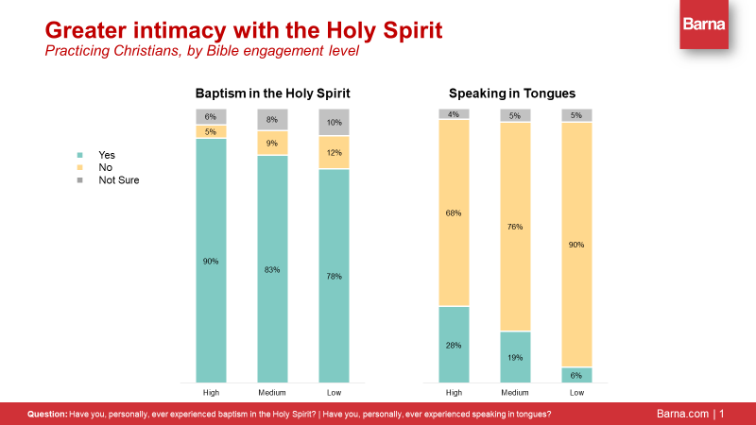

Lives reflecting the fruit of the Spirit
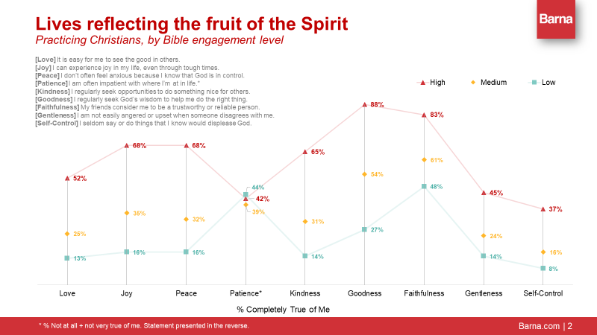

Living my faith in public
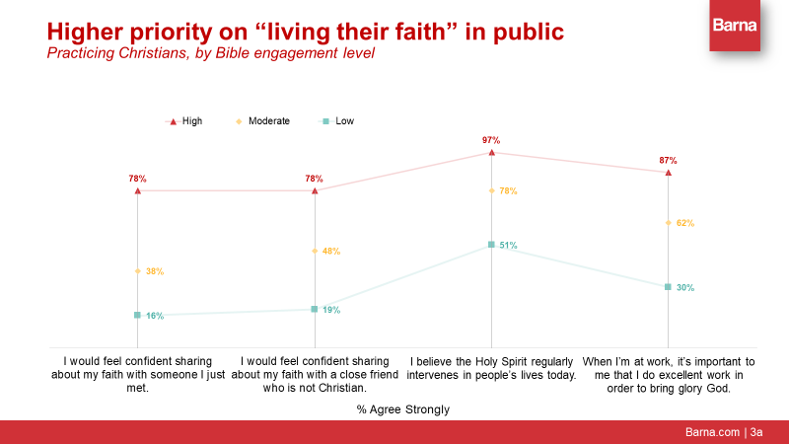

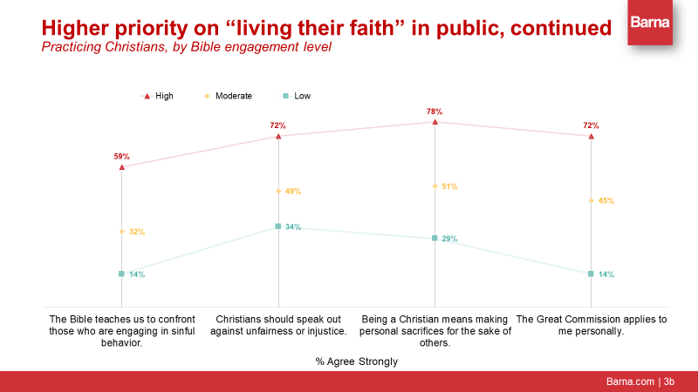
Higher life satisfaction, across the board
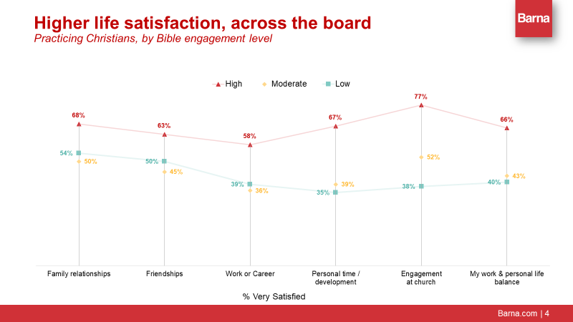
Abraham Maslow’s Hierarchy of Human Needs
